Declining birth rates in Switzerland: Updating subnational trends and subgroup patterns to 2025

Anthony Hauser ^{1,2}, Julien Riou ², Octavio Bramajo ¹, Katarina L Matthes ¹, Tilo Burkhardt ³, Kaspar Staub ^{1,4}

¹ Institute of Evolutionary Medicine, University of Zurich, Switzerland
² Department of Epidemiology and Health Systems, Unisanté, University Center for Primary Care and Public Health and University of Lausanne, Lausanne, Switzerland
³ Department of Obstetrics, University Hospital Zurich, Switzerland
⁴ Population Research Center, University of Zurich, Switzerland

§ Corresponding author: Kaspar Staub, kaspar.staub@iem.uzh.ch

Keywords: Word; Word

Abstract
Background: Birth rates have declined across high-income countries, but national indicators may obscure geographical and demographic differences. We examined recent Swiss birth trends, accounting for population change and postponement of childbearing.
Methods: We analysed individual-level Swiss vital registration data for live births to women aged 15–50 years during 2000–2025. A Bayesian model estimated expected births under a counterfactual of constant underlying fertility, allowing shifts in maternal age at childbirth and accounting for population size and age structure. We compared observed and expected births nationally and examined variation by municipality, population density, maternal citizenship and birth order.
Results: Births declined relative to expectations from approximately 2015 onwards, with observed births 12% below expected in 2025. Estimated age at peak fertility increased from 29.8 years in 2000 to 32.5 years in 2025. A temporary increase in 2021 interrupted the downward trend. During the second half of 2025, the downward trend appeared to level off slightly, although it remains too early to determine whether this represents the beginning of a sustained slowdown. Importantly, the decline was not uniform across Switzerland: urban municipalities experienced substantially larger birth deficits than rural areas, while differences were also observed according to maternal citizenship and birth order.
Conclusions: The recent decline in Swiss births exceeded what could be explained by population structure and delayed childbearing under the modelled counterfactual. Substantial spatial and subgroup heterogeneity highlights the limitations of national averages. These descriptive findings do not establish causes or whether observed period deficits will translate into lower completed cohort fertility.

1. Introduction
Declining fertility has become a defining demographic development across many regions, including high-income societies. In the European Union, the total fertility rate (TFR, the number of children a woman would have if current age-specific fertility rates persisted throughout her reproductive life) fell to 1.34 in 2024.¹ This pattern reflects long-run structural changes associated with the second demographic transition: rising female educational attainment and labour force participation, delayed family formation, increasing infertility and unrealized fertility, and a broad shift toward individualistic life-course norms.^{2–4} Childbearing postponement has been central to these trends, with the share of births to women aged 30 or older rising from 29% to 57% across Europe and other developed regions between 1990 and 2023.⁵ Yet growing evidence suggests the current decline also reflects a genuine quantum reduction in completed fertility, not merely a tempo effect. Hellstrand et al. (2021) showed for the Nordic countries, historically paradigmatic high-fertility, high-gender-equality societies, that women are now having not just later, but fewer children, with cohort fertility declining across successive birth cohorts.⁶ In a comprehensive review of fertility trends in high-income countries, Bloom, Kuhn and Prettner (2024) identify a cluster of mutually reinforcing determinants: the rising opportunity costs of childbearing (particularly for women), housing and economic insecurity, persistent work–family incompatibilities, and cultural shifts toward smaller family norms.⁷ Sustained very low fertility could become the norm rather than a transient phase, with far-reaching consequences for population ageing, pension systems, and long-run economic development. ⁸
The COVID-19 pandemic superimposed a complex pattern of short-term fluctuations on these longer-run trends without reversing them. Sobotka et al. (2024), drawing on monthly birth data from 38 higher-income countries, document a characteristic "pandemic roller-coaster": an initial fall in births in most countries in early 2021, followed by a short-term rebound later that year, and then a pronounced and geographically widespread birth decline from 2022 onwards.⁸ Andersson and colleagues (2024) show for Germany and Sweden that the 2022 decline was particularly sharp with, around 10% in both countries within a few months and associated temporally with vaccination rollout and the easing of pandemic restrictions, but not with conventional economic recession indicators.⁹ At the European level, Vignoli et al. (2021) analysed 251 regions across 28 EU member states, demonstrate that fertility is strongly sensitive to deteriorating labour market conditions, with the steepest declines concentrated in regions where unemployment rose most sharply, pointing to the role of subjective uncertainty and economic insecurity as a driver of reproductive decisions.¹⁰ Recent research further suggests socioeconomic selection into conceptions during the pandemic: Oberndorfer et al. reported a higher representation of births to higher-socioeconomic-status parents in 2021 than in adjacent years. Such compositional shifts underscore the importance of examining aggregate birth trends alongside population subgroups.¹¹
Switzerland exemplifies the post-pandemic fertility trajectory with particular clarity. With a TFR of 1.29 in 2024 (the lowest since records began) Switzerland has seen a steep decline from approximately 1.52 in 2021.¹² This decline predates the pandemic. Matthes, Le Vu and Staub (2025) tracked general fertility rates (GFRs) in Switzerland from 1871 to 2022 using the Swiss vital statistics (BevNat). Their findings show that the GFR had already been declining since the mid-2010s.¹³ This analysis documents that, in contrast to the temporary birth dips followed by baby booms produced by historical influenza pandemics (1889–90, 1918–20, 1957), the COVID-19 period generated more complex dynamics: a transient GFR increase in 2021, concentrated among Swiss-nationality women aged 30 and older and women having their second child, followed by a pronounced decline from February 2022, which disproportionately affected non-Swiss women, women aged under 30, and mothers in German-speaking regions. However, the subgroup analysis in this study was superficial and these patterns warrant closer investigation: national averages cannot show whether declines are concentrated in particular places or population groups, information relevant to understanding demographic inequalities and targeting subsequent explanatory research.
Subnational analyses have consistently shown that national TFRs mask substantial within-country heterogeneity. In Switzerland, cantonal TFRs in 2020 alone ranged from 1.27 in Basel-Stadt to 1.80 in Appenzell Innerrhoden, with cultural, religious and linguistic factors accounting for much of the persistent spatial patterning.^{14,15} The urban–rural gradient is among the most robustly documented subnational differentials across Europe: cities exhibit lower fertility and older maternal age, driven by the concentration of highly educated women and knowledge-sector employment,¹⁶ and also show higher and faster-rising rates of late fertility — births above age 35, compared to rural areas.¹⁷ Economic downturns intensify these spatial inequalities further: in Spain, municipal-level fertility heterogeneity widened markedly during the Great Recession, with the steepest declines in depopulated rural districts,¹⁸ which is a pattern with potential relevance for Switzerland's more peripheral cantons.
Educational and socioeconomic gradients intersect closely with these spatial patterns. Nisén et al. (2021), in the first large-scale comparative study of educational differences in cohort fertility across subnational regions of 15 European countries, find that the negative educational gradient is steepest in the least economically developed regions and flattens or even reverses in the most developed ones, a pattern that holds within as well as across countries.¹⁹ Their more recent work confirms that GDP per capita, childcare availability and industrial composition independently shape parity-specific birth hazards, with complex interactions between women's education and local economic context.²⁰ In German-speaking countries including Switzerland, the fertility decline was moreover primarily driven by falling first-birth rates.²¹ Migration background adds a further layer: foreign-national women in Switzerland maintained a TFR of approximately 1.8–1.9 until around 2018, after which it fell sharply, narrowing the gap with Swiss-born women.¹⁴ Moreover, labour market precarity and economic uncertainty constitute major barriers to fertility realisation across both native and migrant populations.^{22,23}
Despite this rich international literature, systematic subnational analyses of Switzerland's decline in birth rates remains limited, particularly when decomposed by municipality, parity, maternal age, and migration background, and extended through the most recent years. The present paper addresses this gap directly. Drawing on individual-level BevNat data, updated to 2025, we comprehensively expand the subgroup analyses of Matthes et al. (2025) and provide a comprehensive account of which population subgroups have been most affected by Switzerland's fertility decline in recent years, thus contributing to the international literature on the geography and demography of below-replacement fertility.

2. Materials and Methods
Data sources
We used data from several sources. First, we used individual-level Vital Statistics BevNat data routinely collected by the Federal Statistical Office (FSO), including month and year of birth, citizenship, age and municipality of residence of the mother, and parity of the child.²⁴ The data were obtained from FSO in fully anonymized form after signing a data contract. We considered the period 2000–2025 and restricted the sample to live births from mothers aged 15 to 50. Individual-level birth data were then aggregated by month, age and year when calibrating the birth model at the national level, and further by municipality for the computation of excess or deficit of births at the municipality-level. Second, we used population data for women aged 15–50, which were available for different periods depending on the level of stratification required by the analyses. We used national-level population counts for 2000–2025,²⁵ municipality-level population counts for 2011–2025,²⁶ and population counts by country of citizenship for 2011–2025.²⁷ All population datasets were stratified by age (in years) and calendar year, with national- and municipality-level datasets additionally stratified by binary citizenship status (Swiss vs. non-Swiss). Monthly population counts were calculated using linear interpolation. Third, we used municipality-level explanatory variables to characterize spatial differences in fertility.^{28,29} We included FSO data on population density²⁹ and availability of childcare services, measured as the number of employees working in crèches and childcare facilities per 1,000 women aged 15–50 years.³⁰ We also incorporated municipal-level results from four votes related to women’s suffrage, family support and paternity leave from FSO.³¹ In addition, we used the Swiss neighborhood index of socioeconomic position (Swiss-SEP-3), aggregated at the municipality level,³² and an urban–rural typology classifying municipalities into nine categories based on density, size and accessibility.³³ Fourth, we used data from the Swiss Household Panel (SHP) to assess changes in attitudes toward family-related topics at the national level over time.³⁴
Modelling approach
Our aim was to quantify variation in the number of births in Switzerland between 2000 and 2025, over time, municipalities and citizenship, after accounting for changes in the size and age distribution of the female population and shifts towards later childbearing. We measured this variation as the excess or deficit of births, defined as the difference between observed births and the number expected under a counterfactual scenario in which the overall fertility level remained constant over time and space, while the timing of childbearing could change. To establish a common reference for these comparisons, we first fitted a model to national birth counts to estimate the age-specific fertility pattern and predict the expected number of births under this counterfactual. We then downscaled these national predictions to estimate excesses and deficits across more granular strata, such as municipalities and maternal citizenship groups, accounting for their underlying population distributions.
Fitting births at the national level to generate a reference
We fit a Bayesian model for the monthly number of births among women aged 15 to 50 in Switzerland from 2000 to 2025. The model included a baseline log-transformed age-specific fertility function $f$, with temporal changes in the timing of fertility through a shift $δ(t)$ in the age profile. Changes in the size and age distribution of the female population were accounted for using population counts as an offset. We assume that the number of births $y_{a,t}$ for women of age $a$ at month $t$ follows a negative binomial distribution:
$y_{a,t}∼\text{NegBin}\left(μ_{a,t},ϕ\right), log μ_{a,t}=f\left(a+δ(t)\right)+γ_{m}+γ_{y}+logN_{a,t}$,
where $ϕ$ is the overdispersion parameter, $γ_{m}$ is a fixed effect for calendar month $m$, $γ_{y}\sim N(0,σ^{2})$ is a random effect for calendar year $y\left(t\right)$ of standard deviation $σ_{y}$ and $N_{a,t}$ is the number of women of age $a$ at month $t$ included as an offset. The year effect $γ_{y}$ is included to account for dependence between birth counts across age groups within the same year, ensuring appropriate uncertainty estimation.
The year effect is included to account for dependence between birth counts across age groups within the same year, ensuring appropriate uncertainty estimation. However, its fitted year-specific realizations are not used to predict expected births, as this would absorb part of the temporal variation we aim to capture through the estimated excesses or deficits. For the same reason, we fitted the model at the national level rather than using a more granular approach (e.g., incorporating spatial effects), which could account for part of the geographical variation we aim to quantify against a common national reference.
Both functions $f\left(a\right)$ and $δ(t)$ are modelled through Gaussian processes (GP) with exponential kernel. We estimated the model using Hamiltonian Monte Carlo as implemented in Stan (version 2.36) run in R 4.5.1.,³⁵ running four chains of 1,000 warmup and 500 sampling iterations each (2,000 posterior draws in total) and assessed convergence through $\hat{R}$ and effective sample sizes, and we verified the absence of divergent transitions before using the posterior draws. All code is available from https://github.com/anthonyhauser/birth_decline_ch.
Generating the expected/predicted number of births
We used the fitted model to predict the number of births ${\hat{y}}_{a,t}$ for each $a$ and month $t$ under a counterfactual scenario in which the overall fertility level remained constant over time (i.e., removing parameter \gamma_y), while the timing of childbearing could shift across ages. Changes in the size and age distribution of the female population were also accounted for by the offset. We used posterior draws of the model parameters, except for the year effects, which were resampled using the distribution $N(0,σ^{2})$, with σ2 being the hyperparameter measuring a typical yearly variation, estimated from data. This was necessary to remove the yearly trend, thereby ensuring that the predicted birth counts reflected a constant overall fertility level while accounting for residual year-level variability.

Computing the excess or deficit of births
We then define the absolute and relative excess or deficit of births at the national level as the deviations between observed and expected births:
$${\text{Δ}}_{a,t}=y_{a,t}-{\hat{y}}_{a,t}, Δ_{a,t}^{rel}=\frac{y_{a,t}-{\hat{y}}_{a,t}}{{\hat{y}}_{a,t}}.$$

To explore birth excess or deficit at the municipality level, one option would be to fit a spatial model directly to municipality-specific birth counts. However, we could not identify a modelling approach sufficiently flexible to accommodate the parametric shift in childbearing age while remaining computationally efficient with monthly and age-specific stratification across municipalities. We therefore downscaled the national posterior expected births to municipalities, ensuring a common counterfactual fertility reference while accounting for differences in their age-specific female populations. We downscaled the national posterior expected births ${\hat{μ}}_{a,t}$ across $D$ municipalities using a multinomial distribution:
$${\hat{y}}_{1⋯D,a,t}∼\text{Multinomial}\left({\hat{y}}_{a,t},p_{1:D,a,t}\right),$$
where $p_{1:D,a,t}$ denotes the population share of women of age $a$ at month $m(t)$ across municipalities:
pd,a,t=Nd,a,td​Nd,a,t.
The regional excess or deficit of births is defined as:
$${\text{Δ}}_{d,a,t}=y_{d,a,t}-{\hat{y}}_{d,a,t}, Δ_{d,a,t}^{rel}=\frac{y_{d,a,t}-{\hat{y}}_{d,a,t}}{{\hat{y}}_{d,a,t}}.$$
Similar calculations were performed to obtain excess or deficit of births by maternal citizenship, distinguishing between world regions (Switzerland, Western Europe excluding Switzerland, Eastern Europe, North America, Central America, South America, Africa, Asia, and Oceania). Note that excess or deficit of births by municipality and maternal citizenship are only estimated for 2011–2025, due to the availability of population data.
To visualize excess or deficit of births at the municipality level, we smoothed the absolute estimates across neighboring municipalities (i.e. those sharing a boundary or vertex, i.e., queen continguity) to reduce variability in small areas. For each municipality, we computed a weighted average of its own estimate and those of its neighbours, assigning half of the total weight to the municipality itself and distributing the remaining half equally among its neighbours. Relative excess or deficit was then derived from the smoothed absolute excess as described above.
Excess birth stratified by covariates deciles
We further examine excess or deficit of births according to a range of municipality-level variables. For each variable, municipalities are ordered by their value and sequentially grouped into population-based deciles, such that each group contains approximately 10% of the total population. For each decile, we then pool the municipalities belonging to it and summarise the posterior distribution of their combined excess or deficit of births. This outcome is expressed as a relative excess or deficit of births within each decile over the period 2017–2025.
Sub-group analysis
We conducted two subgroup analyses. First, we stratified results by citizenship, distinguishing between Swiss and non-Swiss mothers. Second, we stratified births by parity, separating first births from higher-order births. In each analysis, the model was fitted separately to the corresponding births and population denominators to estimate the excess or deficit of births.
For the parity-based analyses, we could not adjust for the relevant population denominator, as age-specific population counts by parity (i.e. by number of children) were not available. We thus fit the model using the total female population aged 15-50, which slightly modify the fertility function. It should thus be interpreted as the proportion of all women having their first child in a given month rather than a probability, and similarly for higher-order birth analysis.
As a limitation, we could not account for temporal changes in the proportion of childlessness, which may partly explain variation in excess or deficit of first or higher-order births at the national level. Nevertheless, we accounted for spatial differences in childlessness when estimating municipality-level excess or deficit of first births by introducing an estimated share of childless women into the multinomial allocation. This share was reconstructed for each municipality using birth records from 2000–2024, by inferring age-specific childlessness from first births and population counts (see Supplementary Material XX for details). A similar approach was applied for higher-order births.

3. Results
Trends in births and fertility patterns in Switzerland
We fitted monthly births at the national level in Switzerland from 2000 to 2025 and estimated expected births under a scenario of constant underlying fertility level across space and time, accounting for changes in the female population and fertility timing (Fig. 1A). Until the mid-2010s, the increase in expected birth counts, mainly driven by the growing number of women of reproductive age, was exceeded by the increase in observed births. From the mid-2010s, however, observed births declined while expected birth counts stabilized.
The shift in fertility timing towards older ages was captured by the model, with the age at peak fertility increasing from 29.8 years in 2000 to 32.5 years in 2025 (Fig. 1B-C). Under this constant fertility-level scenario, the model implied an average total fertility rate of 1.47 children per woman over 2020–2025. This value is substantially below the replacement level of around 2.1 children per woman required to maintain a stable population in the absence of migration.
Temporal evolution of relative excess births
The relative excess or deficit of births in Switzerland showed the same declining trend over 2017-2025, with the notable exception of 2021 (Fig. 2B). In 2025, observed births were 12% lower than expected under the counterfactual scenario of a constant overall fertility level. In 2021, a temporary increase in births occurred during two distinct periods, at the beginning of the year and in autumn (Fig. 2C). These periods coincided with a delay of slightly more than 9 months after the two COVID-19 waves in Switzerland in 2020, suggesting a potential indirect effect of these initial waves, that were accompanied with non-pharmaceutical interventions including stay-at-home, work-from-home and limited social contacts recommendations (REF), on fertility patterns.
The analysis stratified by maternal citizenship revealed substantial heterogeneity in relative excess or deficit of births across world regions during the recent fertility decline (2017–2025) (Fig. 2D). Mothers with Swiss citizenship showed the largest deficit in births (-10%), whereas mothers from Africa showed the largest excess (62%). Mothers from Western Europe (excluding Switzerland) and Eastern Europe also showed excesses of 2% and 17%, respectively. Despite these differences in the relative excess or deficit of births, all world regions showed a declining trend over 2017-2025 (Fig. 2E).
Spatial variation in birth decline and associated contextual factors
When examining spatial patterns in the relative excess or deficit of births during 2017-2025, we observed substantial variation across municipalities (Fig. 3). Relative deficits were concentrated in major urban agglomerations (e.g., Zurich, Geneva, Basel, Bern), whereas rural areas generally showed excesses. An exception was observed in the southern part of the country, with Ticino and parts of Valais and Grisons showing deficits despite the absence of major urban agglomerations.
We explored heterogeneity in relative excess or deficits of births across municipalities according to a range of municipality-level explanatory variables grouped into deciles (Fig. 4). Municipalities with lower population density showed higher relative excess births, with an excess of around 4% in the lowest-density decile compared with a deficit of -15% in the highest-density decile. Socioeconomic position (SEP) at the municipality level did not show a clear monotonic association, with the highest relative excess births observed among both municipalities with very low and very high SEP levels. Finally, we did not observe positive associations between childcare service density or support for paternity leave extension and relative excess births. Instead, these variables showed negative associations, likely reflecting their correlation with population density.
Subgroup analyses
Subgroup analyses identified several differences across subgroups. Separate analyses were performed for mothers with Swiss and non-Swiss citizenship. The estimated fertility curves showed different patterns by citizenship, with non-Swiss mothers having an earlier but longer fertility profile compared with Swiss mothers (Fig. 5A), resulting in higher average total fertility rates (1.88 vs. 1.35 children per woman, respectively). Despite these differences, both groups showed a clear decline in relative excess births in recent years compared with their respective 2000–2025 levels (Fig. 5B). This decline was more strongly associated with population density among Swiss mothers than among non-Swiss mothers (Fig. 5C).
Separate analyses were also performed by parity, distinguishing first births from second and subsequent births. Both groups showed similar temporal patterns, with a declining trend in the relative excess or decline of births over the last decade (Fig. 5D). The increase in 2021 was almost absent for first births, which also showed little variation according to population density (Fig. 5E). In contrast, higher-order births showed an increase in 2021 and a stronger negative association with population density.

4. Discussion
This study provides an updated and detailed characterization of declining birth rates in Switzerland between 2000 and 2025, with particular attention to geographical and population-level heterogeneity. We found that the decline accelerated from approximately 2017 onwards, reaching a deficit of 12% in 2025 compared with the number of births expected under a scenario of constant underlying fertility, accounting for changes in population structure and the postponement of childbearing. The decline was interrupted by a temporary increase in 2021 but subsequently resumed. During the second half of 2025, the downward trend appeared to level off slightly, although it remains too early to determine whether this represents the beginning of a sustained slowdown. Importantly, the decline was not uniform across Switzerland: urban municipalities experienced substantially larger birth deficits than rural areas, while differences were also observed according to maternal citizenship and birth order. Together, these findings demonstrate that Switzerland's declining birth rates extend beyond changes in the timing of motherhood and in the number of women of reproductive age, and that national averages conceal considerable geographical and demographic heterogeneity.
The sustained decline observed since the mid-2010s is consistent with broader fertility trends across Europe and other high-income countries.^{6,7} An important contribution of our analysis is the explicit consideration of changing population size, age structure, and the postponement of childbearing when estimating expected births. Between 2000 and 2025, the estimated age at peak fertility increased from 29.8 to 32.5 years, illustrating the continuing shift towards later motherhood. Nevertheless, the observed decline exceeded what would be expected from these demographic changes alone. This suggests that postponement is insufficient to account for recent trends and is consistent with international evidence indicating that fertility declines increasingly reflect not only later but also fewer births.⁶ However, our period-based analysis cannot establish whether the observed deficits will translate into lower completed fertility among successive birth cohorts or whether some postponed births will eventually be recuperated.
The COVID-19 pandemic introduced additional short-term fluctuations, including two periods of excess births in 2021 occurring approximately nine months after the major pandemic waves of 2020. Similar fluctuations have been documented internationally,⁸ while previous Swiss research identified a temporary increase in births followed by a pronounced decline from 2022.¹³ The fact that the downward trajectory preceded the pandemic indicates that COVID-19 cannot be considered its sole origin. Whether the pandemic, subsequent economic uncertainty, or other societal developments contributed to accelerating an existing trend remains unresolved.
One of our most striking findings was the pronounced geographical heterogeneity in birth deficits, particularly the urban–rural gradient. Municipalities in the highest population-density decile experienced an average deficit of approximately 15%, compared with an excess of around 5% in the lowest-density decile. This pattern is consistent with previous research documenting lower fertility and later family formation in urban areas, where educational trajectories, labour market participation, housing conditions, and partnership patterns differ from those in rural settings. The stronger decline in urban municipalities could reflect a combination of higher living and housing costs, greater opportunity costs of parenthood, and differences in reproductive preferences or family structures. A recent Swiss Federal Finance Administration (FFA) review identifies housing affordability as one potentially relevant factor, citing Swiss evidence that rising property prices may delay family formation and reduce fertility.³⁶ However, it also notes survey evidence suggesting that the desire to have children does not differ substantially between urban and rural areas, reinforcing the need to distinguish reproductive intentions from constraints on their realization. However, these explanations remain hypothetical because our analyses did not directly investigate the mechanisms underlying the observed spatial differences.
Moreover, the geographical pattern was not exclusively determined by urbanization: Ticino and parts of Valais and Grisons also showed comparatively large deficits despite their lower population densities. Such exceptions suggest that linguistic, cultural, economic, and regional demographic contexts may be relevant alongside urban–rural differences. Our analyses of municipality-level socioeconomic position, childcare availability, and voting patterns related to family policies did not identify straightforward associations that would explain these differences. In particular, the negative ecological associations between childcare availability or support for paternity leave and relative excess births likely reflect their correlation with urbanization rather than evidence that family-supportive environments reduce fertility. These findings underline the importance of distinguishing geographical correlations from causal mechanisms. The FFA review similarly emphasizes that family policies may be introduced in response to low fertility and that cross-sectional associations cannot reliably establish their causal effects; moreover, such policies are often intended to support families rather than increase births.³⁶
The subgroup analyses further revealed that the decline affected populations differently. Mothers with Swiss citizenship showed a larger average birth deficit than mothers with non-Swiss citizenship, although relative excess births declined across all examined citizenship groups over time. Differences in age-specific fertility patterns were also evident, with non-Swiss women displaying an earlier and more sustained fertility profile and a higher estimated fertility level. These findings are consistent with previous Swiss evidence of differences in fertility according to nationality and migration background, but also suggest that the recent decline is not restricted to the Swiss population. Differences between citizenship groups may reflect variation in migration histories, age at migration, family formation patterns, socioeconomic circumstances, and reproductive preferences. Importantly, citizenship is an imperfect proxy for migration background and does not capture these characteristics directly. We also observed differences according to birth order. Whereas first births showed relatively little change during the temporary increase in 2021, second and subsequent births contributed more prominently to this increase and displayed a stronger negative association with population density. This may suggest that decisions concerning family enlargement respond differently to short-term circumstances and local living conditions than decisions to become a parent for the first time. Nevertheless, the underlying reasons cannot be established from our data, and the interpretation of parity-specific patterns is further complicated by incomplete information on the population at risk of first and subsequent births.
Although the present study was not designed to identify the causes of declining birth rates, recent research on reproductive intentions and attitudes provides useful context for interpreting the observed patterns. The 2026 IBSA Foundation report Parenthood in Switzerland, based on the Swiss Assisted Reproduction Longitudinal Study (CHARLS), documents changing perceptions of parenthood and reproductive intentions in Switzerland.³⁷ In a survey of perceived reasons for declining birth rates, respondents most frequently identified professional and personal fulfilment (77%), financial barriers (62%), and changing attitudes and values (49%). The report also highlights an increasing proportion of young adults expressing no desire to have children, alongside continued postponement of parenthood and concerns about financial constraints, personal autonomy, and uncertainty about the future. Complementing these findings, the FFA review reports that the share of Swiss adults aged 20–29 who did not want children rose from 6% in 2013 to 17% in 2023, based on Federal Statistical Office surveys.³⁶ These findings are broadly compatible with the explanations discussed in the international literature, including economic insecurity, work–family incompatibilities, changing life-course expectations, and the increasing individualization of reproductive decisions.^{2,7} The FFA review likewise groups possible explanations into financial costs, difficulties reconciling work and family life, and changing values and lifestyles; its synthesis of international studies suggests that isolated family-policy measures often have modest, context-dependent effects on fertility.³⁶ They may also provide a context for understanding why fertility patterns differ between urban and rural populations and across socioeconomic groups. However, perceived reasons for declining birth rates should not be equated with empirically established determinants of reproductive behaviour. Furthermore, the report highlights both voluntary and involuntary childlessness, including infertility and difficulties realizing reproductive intentions, emphasizing that declining births cannot simply be interpreted as a collective preference for smaller families. Our findings should therefore be understood as documenting where and among whom fertility has declined, rather than explaining why individuals or couples have fewer children. Addressing these questions will require studies linking individual reproductive intentions, socioeconomic circumstances, partnership histories, and access to family support with subsequent fertility outcomes.
Several strengths and limitations should be considered. A major strength is the use of comprehensive individual-level national birth registration data covering 26 years, combined with population denominators and a Bayesian modelling approach that explicitly accounts for changes in the age structure of the female population and the postponement of childbearing. The municipality-level and subgroup analyses provide a more detailed characterization of recent Swiss fertility trends than national aggregate indicators alone. Nevertheless, the expected number of births represents a model-based counterfactual under an assumption of constant underlying fertility, rather than an independently observed benchmark, and the estimated deficits should be interpreted accordingly. Our analyses are descriptive and ecological in nature and cannot identify causal determinants of the decline. Municipality-level characteristics may be correlated with one another, and their associations with birth deficits are vulnerable to ecological fallacy and residual confounding. In addition, population denominators were available at different levels of detail and for different periods, requiring interpolation and assumptions about the municipal population distribution in 2025. The absence of directly observed parity-specific population denominators and changes in childlessness introduces additional uncertainty into the analyses by birth order. Citizenship does not fully capture migration background, and the available data do not allow us to distinguish changes in reproductive intentions from constraints on realizing them. Finally, although our model accounts for changes in fertility timing, we did not directly measure completed cohort fertility. Consequently, we cannot determine to what extent the observed birth deficits reflect a permanent reduction in the number of children women ultimately have, rather than continued postponement of childbearing that may be partially recuperated at older ages.
In conclusion, declining birth rates in Switzerland have become increasingly pronounced over the past decade and cannot be accounted for by changes in population structure and the postponement of motherhood alone. The decline is characterized by substantial geographical and demographic heterogeneity, with particularly large deficits in urban areas and distinct patterns according to maternal citizenship and birth order. Although a slight levelling off was observed during the second half of 2025, it is not yet possible to determine whether this signals a sustained slowdown in the decline or merely a temporary fluctuation. The availability of birth data for 2026, expected in mid-2027, will be important for assessing whether a change in the trajectory is emerging. While economic, social, cultural, and reproductive factors may all contribute to these developments, their respective roles remain to be established. If sustained, low fertility also has longer-term implications for population ageing, labour supply, and public finances, although these outcomes depend importantly on migration, productivity, and other demographic developments.³⁶ Future research should investigate the mechanisms underlying these differences, ideally through longitudinal and multilevel approaches combining demographic records with individual socioeconomic circumstances, reproductive intentions, and local contextual factors. Such evidence will be essential for understanding whether the current decline represents a continuing postponement of parenthood, a more lasting reduction in completed fertility, or a combination of both.

Author statements

Acknowledgements: The authors would like to express their heartfelt gratitude, in particular, to Katja Rost of the Institute of Sociology at the University of Zurich, who sadly passed away in 2026. Katja helped to conceptually design the project on which this publication is based and played a active role in its implementation; we retain fond memories of our excellent collaboration and personal interactions with her. We would also like to thank Jörg Rössel and the members of the Population Research Centre at UZH for their helpful comments on the manuscript.

Funding: This work was supported by a Seed Grant of the UZH Population Research Centre at the University of Zurich.

Conflict of interest: The authors declare that they have no conflict of interest.

Data availability
The code underlying this manuscript are publicly available via GitHub:

Bibliography
1 Eurostat. Fertility statistics - Statistics Explained. 2026. https://ec.europa.eu/eurostat/statistics-explained/index.php?title=Fertility%5Fstatistics (accessed June 19, 2026).
2 Lesthaeghe R. The second demographic transition, 1986–2020: sub-replacement fertility and rising cohabitation—a global update. Genus 2020; 76: 10.
3 Yeatman S, Smith-Greenaway E. Unrealized fertility in demography. Demogr Res 2025; 53: 1145–72.
4 Lazzari E, Beaujouan E. Infertility and Unrealized Ideal Family Size. Popul Dev Rev 2026; 52: 70–93.
5 Spoorenberg T, Skirbekk V. Fertility postponement is not a universal correlate of fertility decline - N-IUSSP. 2026. https://www.niussp.org/fertility-and-reproduction/fertility-postponement-is-not-a-universal-correlate-of-fertility-decline/ (accessed June 19, 2026).
6 Hellstrand J, Nisén J, Miranda V, Fallesen P, Dommermuth L, Myrskylä M. Not Just Later, but Fewer: Novel Trends in Cohort Fertility in the Nordic Countries. Demography 2021; 58: 1373–99.
7 Bloom DE, Kuhn M, Prettner K. Fertility in High-Income Countries: Trends, Patterns, Determinants, and Consequences. Annu Rev Econom 2024; 16: 159–84.
8 Sobotka T, Zeman K, Jasilioniene A, et al. Pandemic Roller‐Coaster? Birth Trends in Higher‐Income Countries During the COVID‐19 Pandemic. Popul Dev Rev 2024; 50: 23–58.
9 Bujard M, Andersson G. Fertility Declines Near the End of the COVID-19 Pandemic: Evidence of the 2022 Birth Declines in Germany and Sweden. European Journal of Population 2024; 40: 4.
10 Matysiak A, Sobotka T, Vignoli D. The Great Recession and Fertility in Europe: A Sub-national Analysis. European Journal of Population 2021; 37: 29–64.
11 Oberndorfer M, Luukkonen J, Remes H, et al. Parental socioeconomic composition of birth cohorts changed during the COVID-19 pandemic. Nat Commun 2025; 16: 11477.
12 Swiss Federal Statistical Office (FSO). Births | Federal Statistical Office - FSO. 2026. https://www.bfs.admin.ch/bfs/en/home/statistics/population/births-deaths/births.html (accessed June 19, 2026).
13 Matthes KL, Le Vu M, Staub K. Fertility dynamics through historical pandemics and COVID-19 in Switzerland, 1871–2022. Popul Stud (NY) 2025; : 1–16.
14 Rausa F, Burkimsher M, Kohli R, Rossi O. Fertility: Cantonal differences. Neuchâtel, 2022.
15 Basten S, Huinink J, Klüsener S. Spatial Variation of Sub-national Fertility Trends in Austria, Germany and Switzerland. Comparative Population Studies 2012; 36. DOI:10.12765/CPoS-2011-08.
16 Riederer B, Beaujouan É. Explaining the urban–rural gradient in later fertility in Europe. Popul Space Place 2024; 30. DOI:10.1002/psp.2720.
17 Setz I, Compans M, Beaujouan É. The Diffusion of Late Fertility Across European Regions (2006–2018). Popul Space Place 2025; 31. DOI:10.1002/psp.70031.
18 Burillo P, Salvati L, Matthews SA, Benassi F. Local-Scale Fertility Variations in a Low-Fertility Country: Evidence from Spain (2002–2017). Can Stud Popul 2020; 47: 279–95.
19 Nisén J, Klüsener S, Dahlberg J, et al. Educational Differences in Cohort Fertility Across Sub-national Regions in Europe. European Journal of Population 2021; 37: 263–95.
20 Nisén J, Klüsener S, Dahlberg J, et al. Economic Conditions, Education and Parity‐Specific Fertility: A Sub‐National Regional Study Across 15 Countries in Europe. Popul Space Place 2025; 31. DOI:10.1002/psp.70074.
21 Zeman K, Beaujouan E, Brzozowska Z, Sobotka T. Cohort fertility decline in low fertility countries: Decomposition using parity progression ratios. Demogr Res 2018; 38: 651–90.
22 Vignoli D, Guetto R, Bazzani G, Pirani E, Minello A. A reflection on economic uncertainty and fertility in Europe: The Narrative Framework. Genus 2020; 76: 28.
23 Estévez JL, Rotkirch A. Fertility trends across migrant generations reexamined: insights from Finnish register data. Eur Sociol Rev 2026; published online March 12. DOI:10.1093/esr/jcag009.
24 Swiss Federal Statistical Office (FSO). Vital Statistics BEVNAT. https://statistik.admin.ch/en/understanding-data-statistics/surveys/bevnat. 2026.
25 Federal Statistical Office (FSO). Demographic balance by age and canton, 1981-2025. 2025. https://www.pxweb.bfs.admin.ch/pxweb/fr/px-x-0102020000_104/-/px-x-0102020000_104.px/.
26 Federal Statistical Office (FSO). Permanent and non-permanent resident population by institutional geographic levels, citizenship (category), sex and age, 2010-2025. 2025. https://www.pxweb.bfs.admin.ch/pxweb/fr/px-x-0102010000_101/-/px-x-0102010000_101.px/.
27 Federal Statistical Office (FSO). Permanent and non-permanent resident population by canton, residence permit, citizenship, sex and age, 2025. 2025. https://www.pxweb.bfs.admin.ch/pxweb/fr/px-x-0103010000_125/-/px-x-0103010000_125.px/.
28 Federal Statistical Office (FSO). Application of Swiss municipalities: Official roster and history tools. 2026. https://www.agvchapp.bfs.admin.ch/fr.
29 Federal Statistical Office (FSO). Population density (productive area) | Map. 2024. https://www.bfs.admin.ch/bfs/fr/home/statistiques/catalogues-banques-donnees.assetdetail.36074341.html.
30 Federal Statistical Office (FSO). Structural Business Statistics (STATENT) 2023: Establishments, employment, and full-time equivalents by municipality and economic branch (NOGA 889100). 2025. https://www.bfs.admin.ch/.
31 Federal Statistical Office (FSO). Popular votes (results at municipal level since 1960). 2026. https://www.pxweb.bfs.admin.ch/pxweb/fr/px-x-1703030000_101/-/px-x-1703030000_101.px/.
32 Panczak R, Berlin C, Voorpostel M, Zwahlen M, Egger M. The Swiss neighbourhood index of socioeconomic position: update and re-validation. Swiss Med Wkly 2023; 153: 40028.
33 Federal Statistical Office (FSO). Geographic levels - results: Municipal Typology 2020 (as of 01.01.2026). 2026. https://www.agvchapp.bfs.admin.ch/fr/typologies/results?SnapshotDate=01.01.2026&SelectedTypologies%5B0%5D=HR_GDETYP2020.
34 Voorpostel M, Tillmann R, Lebert F, et al. Swiss Household Panel User Guide (1999-2024), Wave 26. 2026; published online March. https://forscenter.ch/wp-content/uploads/2026/03/shp_user_guide.pdf.
35 Carpenter B, Gelman A, Hoffman MD, et al. Stan: A Probabilistic Programming Language. J Stat Softw 2017; 76: 1–32.
36 Lerch B, Brändle T, Baur M. Low fertility rates: A fiscal policy perspective. FFA Working Paper No. 30. Bern, 2026.
37 Christen A, Corba E, Fritsch L, et al. Parenthood in Switzerland. A Report on (In)Fertility and Childlessness. 2026.

Figures
Figure 1: Model fit. A. Monthly number of births, as observed (red points) and expected (black lines corresponding to the mean posterior and gray area to the 95% credibility interval (95% CrI)), from 2000 to 2025. B. Fertility curve. Probability of having a child (by month) according to maternal age for different calendar years (2000, 2010 and 2025). C. Age of fertility peak according to calendar year.
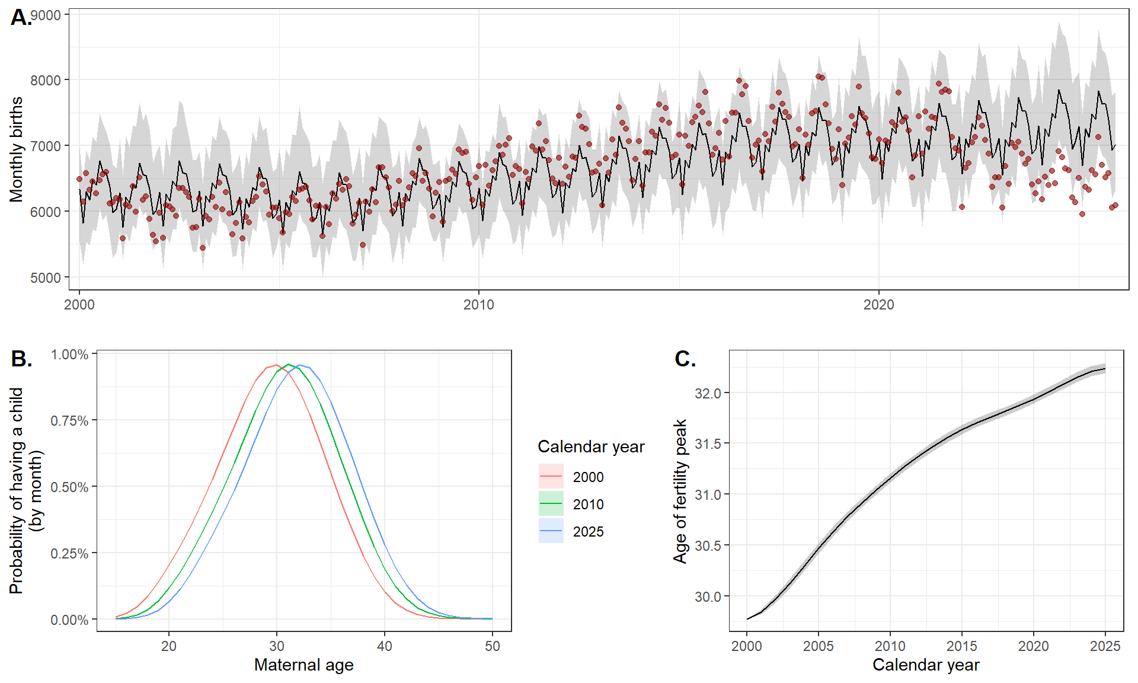

Figure 2: Excess and deficit of births. A. Annual number of births, as observed (red points) and expected (black lines corresponding to the mean posterior and gray area to the 95% credibility interval (95% CrI)), from 2000 to 2025. B. Relative excess birth by year from 2000 to 2025. C. Relative excess birth by month between 2020 and 2025. D. Relative excess birth by citizenship aggregated by region of the world in 2011-2025. E. Relative excess birth by citizenship over years.

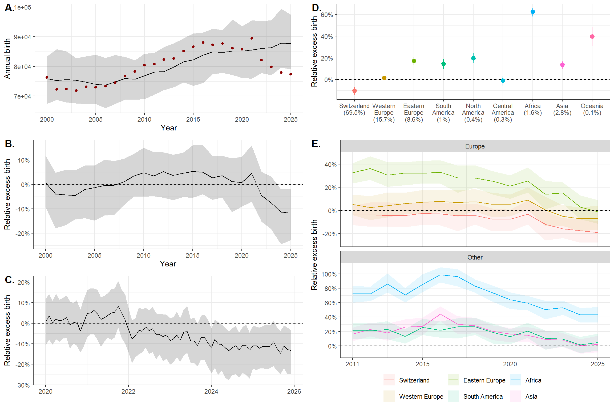

Figure 3: Excess and deficits of births by municipality. Relative excess birth by municipality between 2017 and 2025.

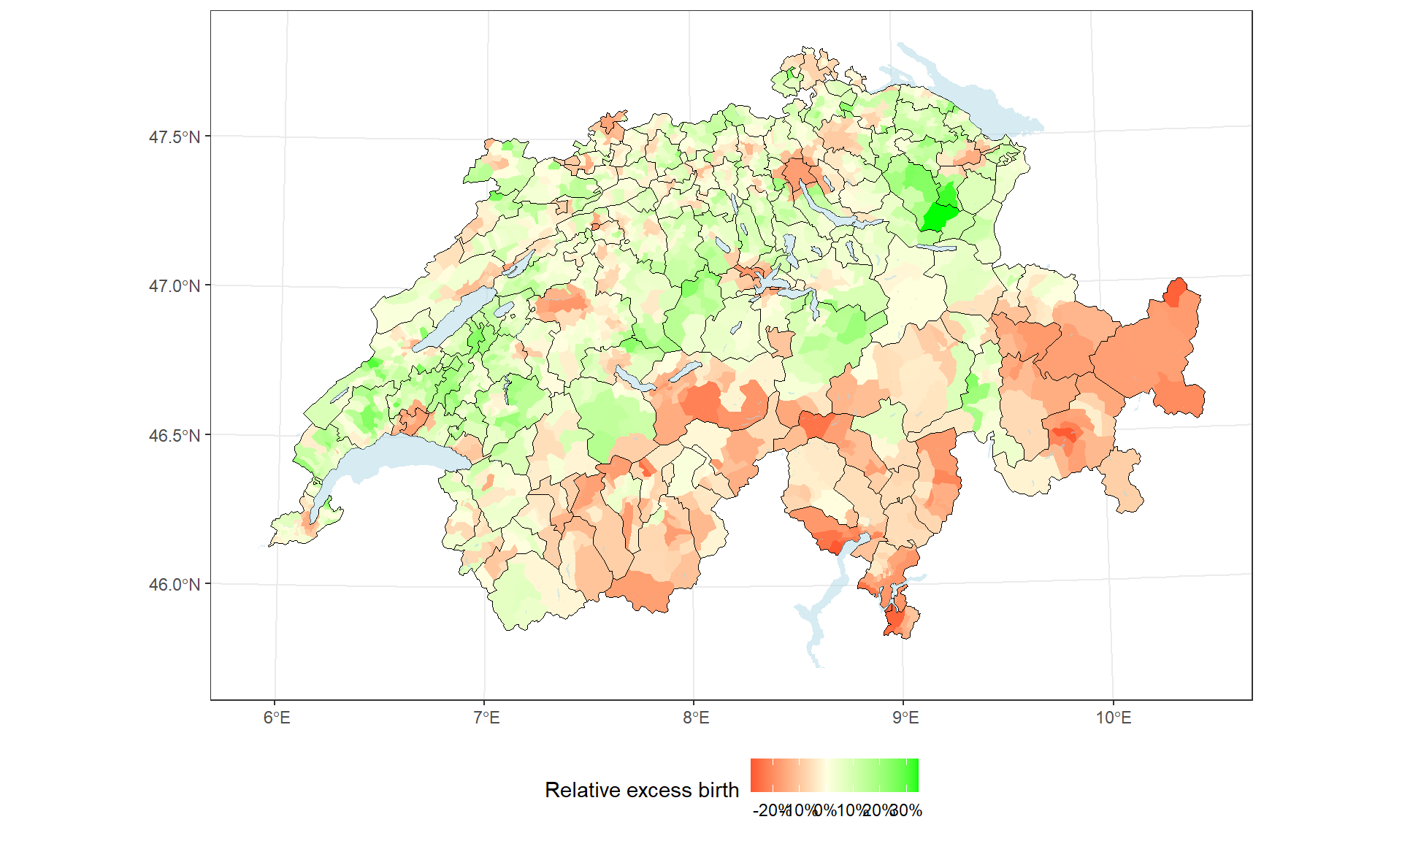

Figure 4: Excess and deficit of births stratified by municipality-level variable deciles: Relative excess births according to four municipality-level variables: population density, childcare service density, socioeconomic position (SEP), and the share of votes supporting the introduction of paid paternity leave in the Swiss popular vote of 2020.

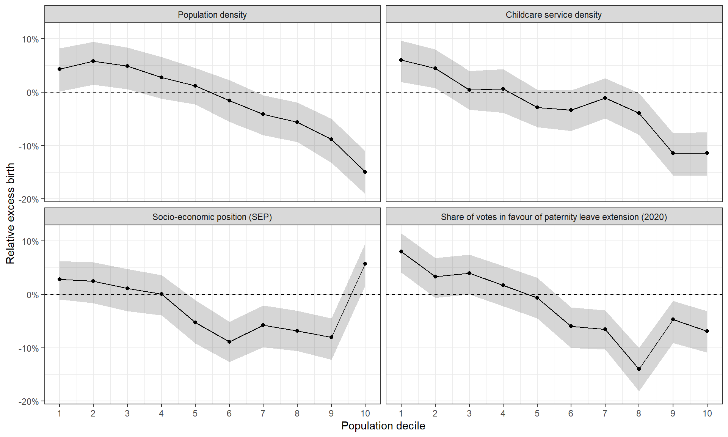

Figure 5: Sub-group births: A. Fertility curve by maternal citizenship. Probability of having a child per month according to maternal age for Swiss (red) and non-Swiss (yellow) residents. B. Relative excess births by year from 2000 to 2025 according to maternal citizenship. C. Relative excess births according to municipality-level population density deciles, by maternal citizenship. D. Relative excess births by year from 2000 to 2025 according to birth parity, distinguishing first births (green) from higher-order births (blue). E. Relative excess births according to municipality-level population density deciles, by birth parity. The estimate from the main analysis (black line) is shown for comparison. Lines represent posterior means and shaded areas the 95% credible intervals (95% CrI).



